(Organization Letterhead)
INTERNSHIP OFFER LETTER

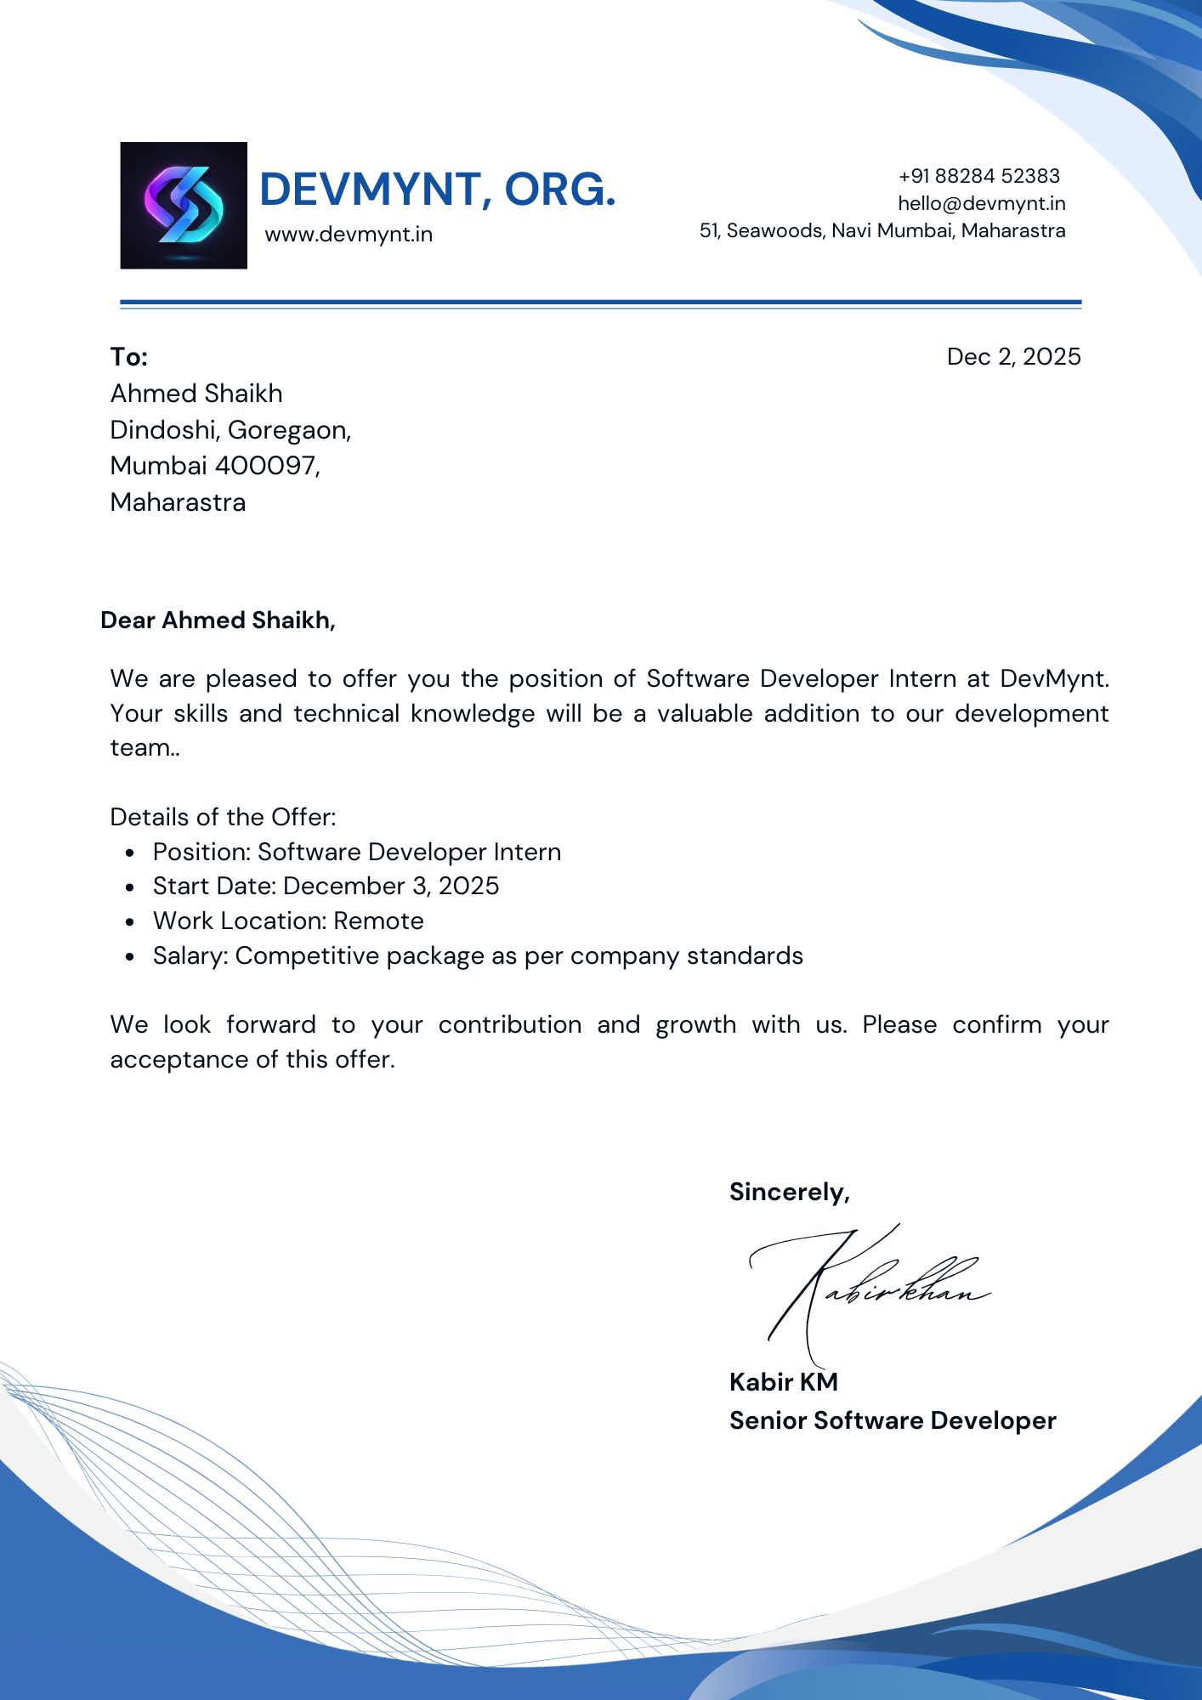

ABOUT ORGANIZATION
About Organization – DevMynt
DevMynt is an IT services and software development company that focuses on building modern web applications and providing innovative digital solutions. The organization specializes in full-stack development, working with technologies such as the MERN stack (MongoDB, Express.js, React.js, Node.js) to develop scalable and efficient applications.

DevMynt operates in domains such as web application development, CRM systems, and E-commerce platforms. The company emphasizes practical implementation, real-time project exposure, and hands-on development experience, enabling interns and developers to work on live projects using industry-relevant tools and technologies.

The organization provides opportunities to work on real-world projects involving frontend development, backend API development, database management, and third-party integrations. This helps in building strong technical skills, problem-solving abilities, and a clear understanding of modern web application architecture.

During my association with DevMynt, I gained valuable experience in full-stack development. I worked on projects such as CRM and E-commerce applications, where I developed user interfaces using React, built RESTful APIs using Node.js and Express, and managed data using MongoDB. I also implemented payment gateway integration using Razorpay and deployed applications using platforms like Vercel and Render.

Through this training, I developed practical skills and gained insight into how real-world software applications are designed, developed, deployed, and maintained in a professional environment.

OJT UNDERTAKING

Student Name | Ahmed Shaikh
Current Address | Flat no.405, Azad Building, Dindoshi Depot, Goregaon East  Mumbai 400097
Residence Address | Flat no.405, Azad Building, Dindoshi Depot, Goregaon East  Mumbai 400097
Email ID | theahmed619@gmail.com
Mobile No | 7718972116
Aadhar Card | ***********
PAN Card
Overall GPA
Mode of Internship | Online
I confirm that I agree with the terms, conditions, and requirements of the OJT Policy.

Student Signature Date :
I confirm that the student has attended the OJT orientation, and he has met all paperwork and process requirements to participate in the OJT programme and has received approval from his mentor.

Coordinator

Date :

PROGRESS REPORT FOR THE MONTH OF JANUARY 2026
Organization Name | Date of Report | Student Signature
DevMynt | 20/01/2026
Name of Student | Ahmed Shaikh
Reporting Person Name and Designation | Kabir, Senior Software Developer
Reporting Person’s Contact Details | 91206 28997
Job Description and Responsibilities | During this month, I worked as a Software Developer Intern where I contributed to full-stack web development using the MERN stack (MongoDB, Express.js, React.js, Node.js). I was involved in developing and optimizing frontend components using React, building and integrating RESTful APIs using Node.js and Express, and handling database operations with MongoDB.
Technology Used during Internship | JavaScript  Node JS  React JS  MongoDB  VS Code
Overall Learning Experiences | Learning Experience | I strengthened my understanding of full-stack development and improved my ability to build scalable web applications.
 | Skills Learnt | - Frontend Development (React)  - API Development  - Database Handling
 | Knowledge Acquired | - Understanding of MERN stack architecture  - Client-server interaction and API flow
Personal SWOC Analysis during Internship | Strength | - Quick learner  - Strong analytical thinking  - Good problem-solving skills
 | Weakness | - Sometimes overthink solutions  - Limited real-world experience (improving through practice)  - Time management needs improvement in complex tasks  - Tendency to focus too much on perfection
 | Opportunities | Gained hands-on experience with real-world projects
 | Challenges | Debugging application issues and managing backend logic

MONTHLY REPORT

PROGRESS REPORT FOR THE MONTH OF FEBRUARY 2026
Organization Name | Date of Report | Student Signature
DevMynt | 25/02/2026
Name of Student | Ahmed Shaikh
Reporting Person Name and Designation | Kapil, Senior Software Developer
Reporting Person’s Contact Details | 91206 28997
Job Description and Responsibilities | During this month, I worked on real-world projects such as CRM and E-commerce applications. I developed dynamic user interfaces using React and handled backend services using Node.js and Express. I also performed database operations using MongoDB and implemented features like authentication and data management.
Technology Used during Internship | JavaScript  Node JS  React JS  MongoDB  JWT  VS Code
Overall Learning Experiences | Learning Experience | I gained practical experience in building real-world applications and managing complete full-stack workflows.
 | Skills Learnt | - Full-stack Development  - CRUD Operations  - Problem Solving
 | Knowledge Acquired | - API integration in applications  - Insight into industry-level project development
Personal SWOC Analysis during Internship | Strength | - Adaptable to new technologies  - Ability to work independently and in a team
 | Weakness | Time management in complex modules
 | Opportunities | Worked on live projects like CRM and E-commerce systems
 | Challenges | Handling backend logic and debugging errors

MONTHLY REPORT

PROGRESS REPORT FOR THE MONTH OF MARCH 2026
Organization Name | Date of Report | Student Signature
DevMynt | 22/03/2026
Name of Student | Ahmed Shaikh
Reporting Person Name and Designation | Kabir, Senior Software Developer
Reporting Person’s Contact Details | 91206 28997
Job Description and Responsibilities | In this month, I worked on advanced features such as payment gateway integration using Razorpay API. I also deployed applications using platforms like Vercel and Render. Additionally, I worked on debugging, performance optimization, and improving overall application functionality.
Technology Used during Internship | JavaScript  Node JS  React JS  MongoDB  JWT  Vercel  VS Code
Overall Learning Experiences | Learning Experience | I gained hands-on experience in deploying full-stack applications and integrating third-party APIs.
 | Skills Learnt | - Payment Gateway Integration  - Deployment (Vercel, Render)  - Debugging & Optimization
 | Knowledge Acquired | - Understanding of production-level deployment  - API integration for Payment Gateway  - Performance optimization techniques
Personal SWOC Analysis during Internship | Strength | - Quick learner  - Strong analytical thinking  - Good problem-solving skills  - Adaptable to new technologies  - Ability to work independently and in a team
 | Weakness | Tendency to focus too much on perfection
 | Opportunities | • Gained hands-on experience with real-world projects  • Exposure to industry-level tools and technologies  • Improved technical and analytical skills  • Enhanced career readiness and confidence
 | Challenges | Debugging deployed applications and meeting deadlines

ATTENDANCE SHEET

Name & Address of Organization DevMynt Organization,

Navi Mumbai, Maharashtra
Name of the Student |  |  |  | Ahmed Shaikh
Seat Number |  |  |  | MIT251009
Name of Course |  |  |  | MSC IT Part I
Date of Commencement of Training |  |  |  | January 2026
Date of Completion of Training |  |  |  | March 2026
Week | Monday | Tuesday | Wednesday |  | Thursday | Friday | Saturday
1 | 02-12-2025 | 03-12-2025 | 04-12-2025 |  | 05-12-2025 | 06-12-2025 | 07-12-2025
 | (Sign) | (Sign) | (Sign) |  | (Sign) | (Sign) | (Sign)
2 | 09-12-2025 | 10-12-2025 | 11-12-2025 |  | 12-12-2025 | 13-12-2025 | 14-12-2025
 | (Sign) | (Sign) | (Sign) |  | (Sign) | (Sign) | (Sign)
3 | 16-12-2025 | 17-12-2025 | 18-12-2025 |  | 19-12-2025 | 20-12-2025 | 21-12-2025
 | (Sign) | (Sign) | (Sign) |  | (Sign) | (Sign) | (Sign)
4 | 23-12-2025 | 24-12-2025
 | (Sign) | (Sign)
5
6
7
8
9
10
11
12

COMPLETION CERTIFICATE

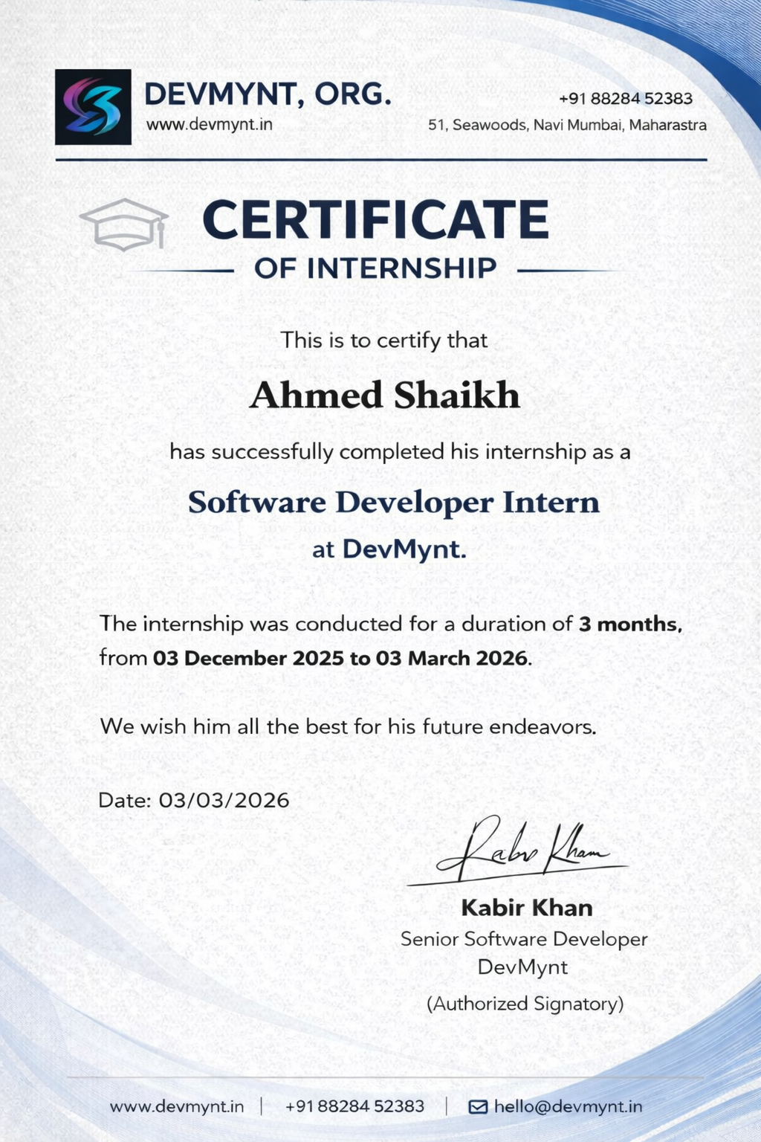

STUDENT FEEDBACK OF OJT

Student Name: Ahmed Shaikh Date :
Organization Supervisor : Kabir Khan Title : Team Leader Supervisor Email : kabirdevmynt@gmail.com OJT is : ⬜ Unpaid ⬜ Paid Organization : DevMynt
Organization Address : Navi Mumbai , Maharastra

Department : Information Technology

Dates of OJT : From : 20/01/2026 To : 23/03/2026

Give a brief description of your OJT work (title and tasks for which you were responsible) :
Was your internship experience related to your major area of study ?
⬜ Yes, to a large degree.
⬜ Yes, to a slight degree.
⬜ No, not related at all.

Indicate the degree to which you agree or disagree with the following statements.

This experience has | Strongly Agree | Agree | Neutral | Disagree | Strongly Disagree
Given me the opportunity to explore a career field
Allowed me to apply classroom theory to practice
Helped me develop my decision making and problem-solving skills.
Expanded my knowledge about the work world before permanent employment.
Helped me develop my written and oral communication skills
Provided a chance to use leadership skills (influence others, develop ideas with others, simulate decision making and action)

This experience has | Strongly Agree | Agree | Neutral | Disagree | Strongly Disagree
Expanded my sensitivity to the
ethical implications of the work involved
Made it possible for me to be
more confident in new situations
Expanded my sensitivity to the ethical implications of the work involved
Made it possible for me to be
more confident in new situations
Given me a chance to improve
my interpersonal skills
Helped me learn to handle responsibility and use my time wisely
Helped me discover new aspects of myself that I didn’t know
existed before
Helped me develop new interest
and abilities
Helped me clarify my career goals
Provided me with contacts which may lead to future employment
Allowed me to acquire information and/or use equipment not available at my
Institute

In the Institute OJT program, faculty members are expected to be mentors for students. Do you feel that your faculty coordinator served such a function? Why or why not?
The faculty coordinator provided necessary guidance during the OJT program by monitoring progress and offering general instructions. While most of the learning was self-driven, the support provided was helpful in completing the training successfully. More frequent interaction and detailed feedback could have further enhanced the overall learning experience.

How well were you able to accomplish the initial goals, tasks and new skills that were set down in your learning contract? In what ways were you able to take a new direction or expand beyond your contract? Why were some goals not accomplished adequately?
I was able to accomplish most of the initial goals and tasks outlined in my learning contract. I successfully applied my knowledge of full-stack development by working on real-world applications such as CRM and E-commerce systems. I also gained hands-on experience in API development, database integration, payment gateway implementation, and deployment using platforms like Vercel and Render, which helped me expand beyond the initial scope of learning.

In what areas did you most develop and improve?
During my OJT, I showed significant improvement in full-stack development and problem-solving skills. I enhanced my knowledge of React, Node.js, and MongoDB, and gained practical experience in building scalable web applications. I also improved my debugging skills, time management, and ability to handle real-world project requirements.

What has been the most significant accomplishment or satisfying moment of your OJT? The most significant accomplishment during my OJT was successfully developing and deploying full-stack applications. Integrating the Razorpay payment gateway and deploying projects on platforms like Vercel and Render was a very satisfying experience, as it allowed me to build real-world, production-ready applications.

What did you dislike about the OJT?
One aspect I found challenging during the OJT was the limited level of continuous mentorship, which sometimes required extensive self-learning. However, this also helped me become more independent and improved my problem-solving abilities.

Considering your overall experience, how would you rate this OJT? (Circle one).
Satisfactory / Good / Excellent

Give suggestions as to how your OJT experience could have been improved. (Could you have handled added responsibility? Would you have liked more discussions with your professor concerning your OJT? Was closer supervision needed? Was more of an orientation required?)
The OJT experience could have been improved with more regular mentorship sessions and detailed feedback. A structured orientation at the beginning and more collaborative discussions would have enhanced the learning process. I also feel I could have taken on additional responsibilities to gain deeper practical exposure.

(Student Signature)
Name: Ahmed Shaikh
Seat No: MIT251009

Date :

RESUME

